Soft Condensed Matter Physics
Dr Nigel Wilding (3West 3.3(B), N.B.Wilding@bath.ac.uk)

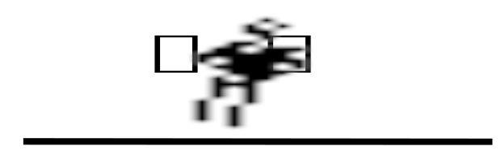 | - Introduction: Characteristic features and random walks.
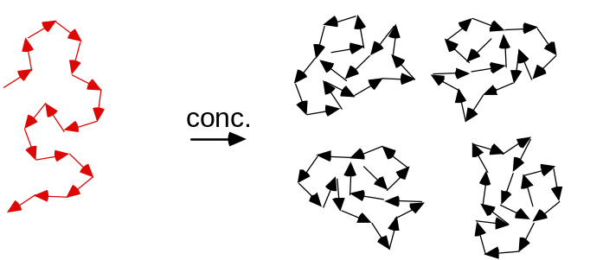 | Part 1: COLLOIDS  (2) Brownian motion  (3) Interacting colloidal suspensions
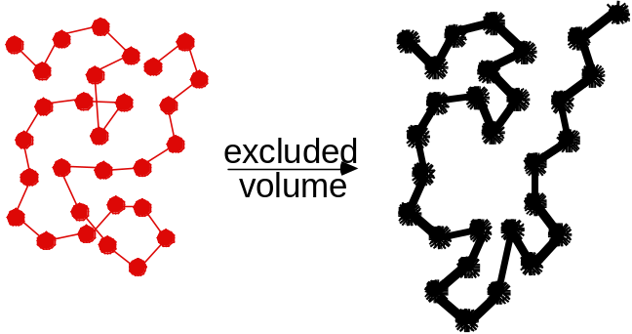 | Part 2: POLYMERS  (4) Chemical structure  (5) Polymer conformations  (6) Concentrated polymer solutions
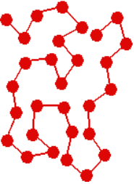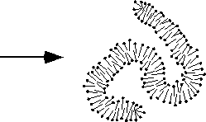 | Part 3: SURFACTANTS  (7) Chemical structure  (8) Self-assembled structures

- Introduction and Motivation

Soft condensed matter physics, or macromolecular physics, or the physics of complex fluids, is the study of colloids, polymers and surfactants. All these systems contain structural units in the colloidal length scale, 1nm <R <1 µm.

  - Systems and definitions

• Colloid: disperse phase (solid, liquid or gas 'particles') distributed in a finely divided state in a dispersion medium (solid, liquid or gas 'solvent'). Examples:

• Polymers:
- Large molecules composed of many monomers.
- Covalent chemical bonds.
- Different architectures: linear-chain homopolymers, (block) copolymers, starpolymers, dendrimers etc.
- We concentrate on linear chains,
- Examples: polyethylene, cellulose, DNA, proteins.

• Surfactant (SURFace ACTive AgeNT)
- Special kind of molecule.
- Hydrophilic 'head group',

- Hydrophobic 'tail'.
- Above a certain concentration spontaneously self-assemble into a wide variety of structures
- Simplest is spherical micelle.
- Associate (group together) by rather weak physical interactions ('association colloids').
- Examples: Sodium
Dodecylsulfate (SDS), lipids.

1.2 Macromolecules: principal distinguishing features

1.2.1 Size Range (1nm <R <1 µm)
Lower limit (about 1 nm):
- Ensures size of the dispersed particles >> size of the molecules forming the dispersion medium.
- Distinguishes colloids from ordinary (true) solutions,
- Results in a 'well-defined' interface between the particles and the surrounding medium ⇒treat the dispersion medium as a continuum and avoid quantum mechanics.

Upper limit (about 1 µm):

• Balance of thermal and potential energy:
Every particle has thermal energy Etherm = (3/2) kBT and potential energy Epot = mgz = (4π/3) R3Δρgz.

For a significant influence of the thermal energy need Epot < Etherm and thus for a typical system (Δρ ≈ 0.3 g cm-3): R < (9kBT / 8πΔρ g)1/4 ≈ 1 µm.

1.2.2 Sedimentation

- Gravity leads to sedimentation of the suspended particles and formation of a dense sediment.

- The sedimentation velocity vsed results from the balance of gravity and hydrodynamic drag:

gravity (sphere)
↓

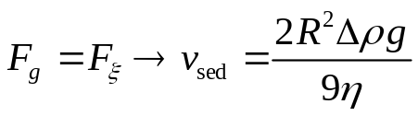

friction (Stokes law) sphere:
↓

Here m is mass, ρ the density of the particle (part) and liquid (liq), respectively, Δρ the density difference, V the volume and R the radius of the particle, η the viscosity, v the sedimentation velocity and g the acceleration due to gravity.

1.2.3 Brownian motion and random walks
Random collisions with the liquid molecules → colloid particle changes direction of motion rapidly. Model as a random walk of N steps of length b with a random angle between the individual steps. How far from the origin does the particle get in N steps?

Average over many tries (or many particles):
<R> = = 0 since rj can be in any direction
Mean square displacement:
<R2> = <R·R> = < · > =
j = k: <rj · rk> = <rj2> = b2
j ≠ k: <rj · rk> = b2 <cosθ> = 0 since any θ in 0 <θ <2π
Hence <R2> = = Nb2 ∝ t since time t ∝ N

Actually find that <R2>1/2 = ∝ where for spherical particles the diffusion constant D = kBT/6πηR with R the particle radius.

Example: Uncharged protein spheres in water (ρprotein = 1.35 g cm-3) at 20°C (η = 1 Ps). Calculate the displacement due to Brownian motion and sedimentation respectively as a function of the particle radius R.

For Brownian motion: 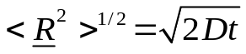 with 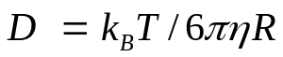
For sedimentation: 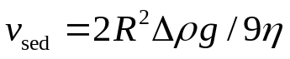
Hence can plot particle displacement versus radius.

R | D (20°C) | (<R2>)1/2 after 1h |  | vsed × 1h
1 nm | 2.1·10-10 m2/s | 1230 µm | > | 2.8 nm
10 nm | 2.1·10-11 m2/s | 390 µm | > | 0.3 µm
100 nm | 2.1·10-12 m2/s | 123µm | > | 30 µm
1 µm | 2.1·10-13 m2/s | 39 µm | < | 3 mm
10 µm | 2.1·10-14 m2/s | 12 µm | < | 0.3 m

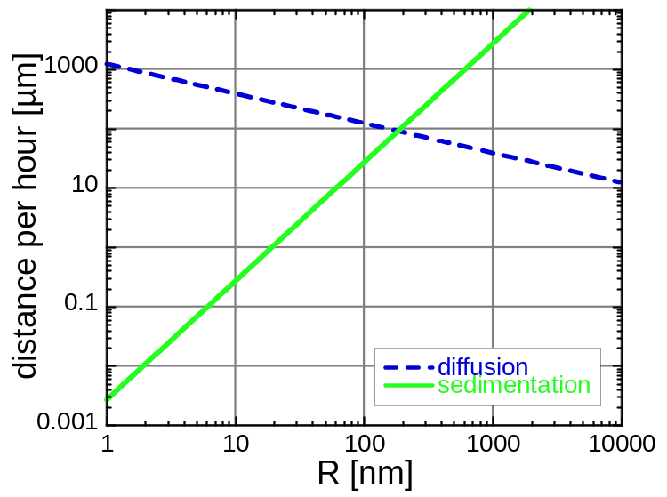

More generally probability of finding a particle at a given vector displacement from its starting point is given (in 1 dimension) by
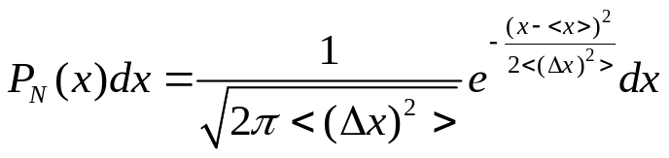 A 1d Gaussian distribution
Mean 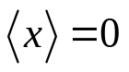and variance 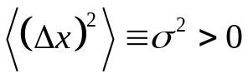.

In 3 dimensions, the corresponding relation is
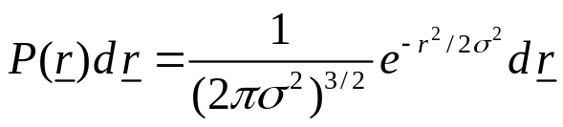 A 3d Gaussian distribution.
This distribution has its first moment at the origin and second moment 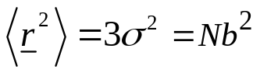

1.2.4 Large interface between dispersed phase and dispersion medium

- Often want to produce soft matter systems with (chemical) properties intermediate between those of bulk and molecularly dispersed systems

- To achieve this, a significant proportion of the molecules should lie within or close to the particle-medium interface, i.e. large surface-to-volume ratio.
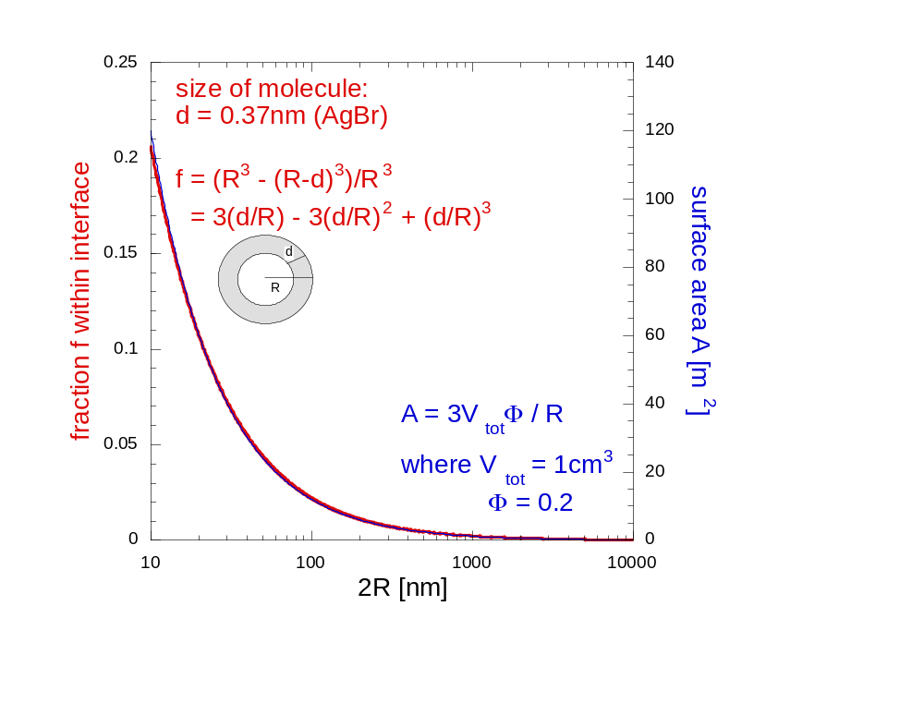
- Often colloidal particles have a spherical shape, which allows for a relatively small surface-to-volume ratio, but they may also be ellipsoids (prolate or oblate), discs, rods, fibres, random coils etc.

1.3 Making measurements: Scattering experiments

- The most commonly used experimental tool for studying soft matter systems is scattering (light, neutrons or X-rays etc).

- Due to the random arrangement of particles, a random diffraction pattern is observed. This fluctuates as particles move in Brownian motion.

- Scattered intensity as measured under a certain scattering angle will thus also fluctuate with time (given the detector area is small enough).

Part 1: COLLOIDS

(2) Brownian Motion

2.1 Diffusion
- Calculated probability that after N steps a single particle will be found in volume element dr centred at r. Found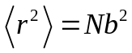, which suggests 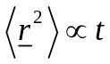.

- What about when many particles each undergo an independent random walk? Can ask what fraction will be in a certain volume element after time t? This is the process of diffusion, e.g. spread of a drop of colour ink in water.

Mathematics: Suppose that the distribution of particles n(x,t) is not uniform→ motion of particles (diffusion) tending to increase entropy and restore a homogeneous concentration.

- Interested in time-dependent concentration (number per unit volume) profile of particles n(x,t). In the case of an initially very narrow spatial distribution of particles this will correspond to the probability of any particle having moved to x.

- The mean number of particles crossing unit area of a plane (perpendicular to the x-axis) per unit time (i.e. the 'flux'), is denoted by Jx. This flux is expected to be (to a good approximation) proportional to the concentration gradient:

where the diffusion constant (or coefficient) D has been defined as the constant of proportionality.
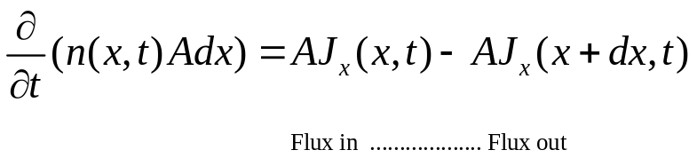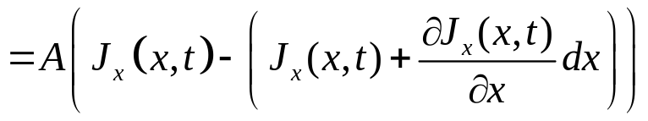Now, conservation of particle number demands

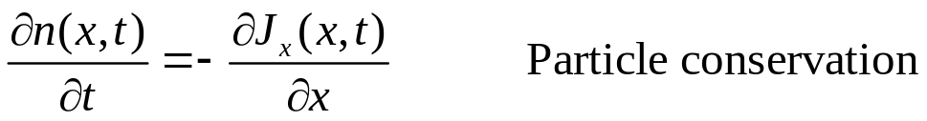and thus

Fick's law and particle conservation together give (assuming D ≠ D(x)):
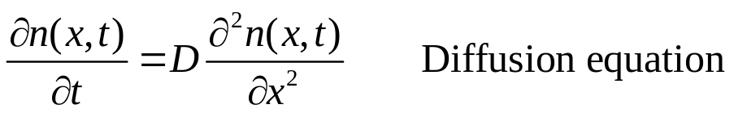
The solution, up to a constant C, which satisfies the initial condition (t=0) of having all the particles close together at x=0 is
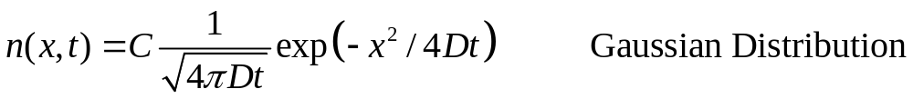
The constant C can be determined by
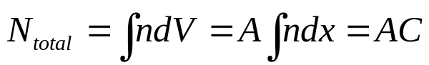
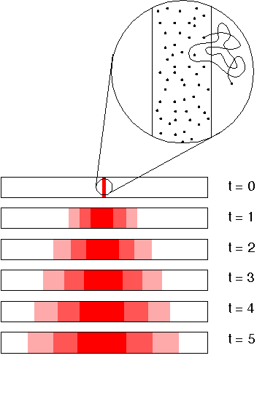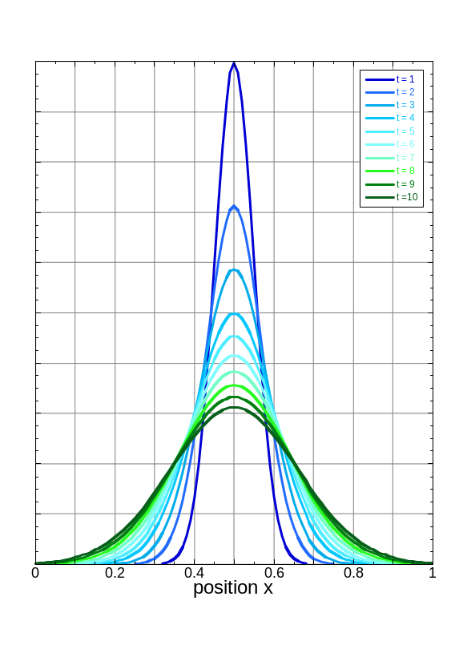
But the spreading of the particle distribution with time is due to the random walk of individual particles, for which
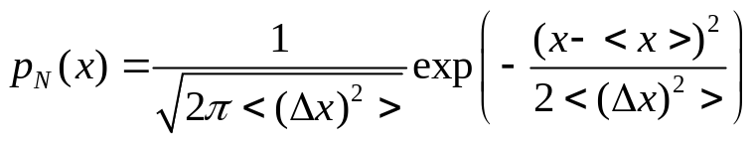
Comparing the result from the two points of view and setting <x> = 0, we get <Δx2> = 2Dt.
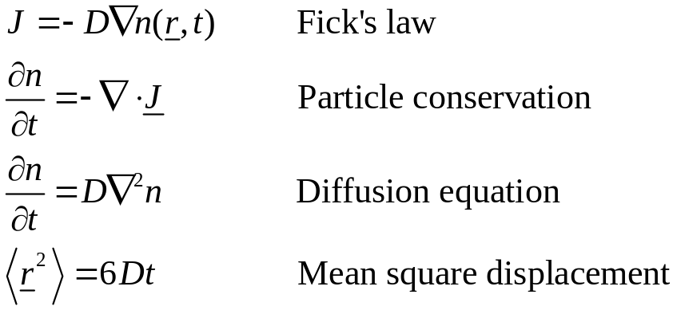
Generalisation to three dimensions yields:

2.2 Stokes-Einstein relation

- Suppose particles are subjected to an external force F in the x direction, e.g. gravity. In thermal equilibrium the Maxwell-Boltzmann distribution is valid, i.e. the particle density n(x) is given by
- For gravity, F = m_{B}g with m_{B} the buoyant mass.

- n(x) results from the balance between the motion of the particles due to the external force setting up a concentration gradient, and the resultant diffusion given by Fick's law.

In the case of gravity, this leads to a sedimentation
equilibrium.

(a) Flux due to external force, J_{F}
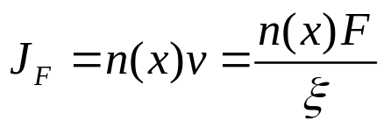Particle velocity under an applied force F in a viscous fluid can be written as v = F/ξ, which defines the friction coefficient ξ. Hence

(b) Diffusive flux, J_{D}
J_{D} is given by Fick's Law (see above):

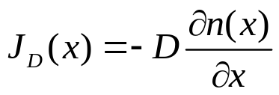
Equating the two fluxes J_{F} = J_{D} we get

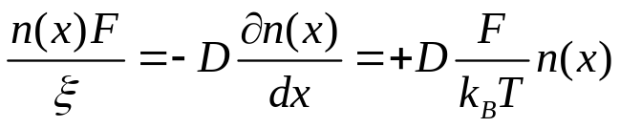

This gives the relation between the diffusion and friction coefficients:
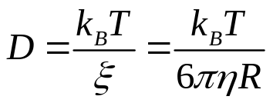
The last equation applies to a spherical particle of radius R in a fluid of viscosity η, for which Stokes’s Law gives ξ = 6πη resulting in the Stokes-Einstein relation.

(3) Interacting colloidal particles

- So far dealt with colloidal particles as independent spheres suspended in a dispersion medium. Now we will study concentrated suspensions in which interparticle interactions cannot be ignored.

3.1 Samples: model hard-sphere colloids

- To be specific let us discuss a monodisperse colloid made up of polymethylmethacrylate

- Particle radius 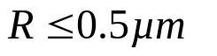with a very small polydispersity (size variation) of 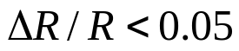.

- Usual to measure particle densities via the 'volume fraction' φ: fraction of the suspension occupied by particles. For N monodisperse spheres with radius R in the total volume V,

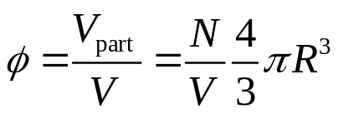

3.2 Phase Behaviour

- Recall the interaction potential and phase behaviour of a simple atomic substance, such as argon.
- A generic inter-particle potential U(r) exhibits the infinite hard sphere repulsion as well as an attractive part of depth ε.

- Corresponding phase diagram in the temperature-density plane shows where gas, liquid, fluid and crystal exist. A rough estimate of the critical temperature Tc is given by kBTc ~ ε. If ε → 0, as in the case of hard spheres, we expect that there will be no critical point and therefore no liquid phase.

Phase behaviour of hard-sphere colloids:

- At very low densities, the structure of a hard-sphere suspension is like that of a perfect gas; the positions of the colloidal particles are practically uncorrelated and the chance of finding a particle in any particular vicinity is almost independent of the presence of all the other particles.

- At larger particle densities, positions begin to become correlated as the particles are mutually excluding.

If we look inside a suspension of volume fraction φ ≥ 0.3, find that, at any one instant, each particle is surrounded by a `cage’ of neighbours (short-ranged order). The cage tightens as φ increases. The cage size represents a dominant length scale in the system.

- Despite correlations, a hard-sphere suspension below φ <0.5 is still a 'colloid fluid' - on average the particle centres are more or less randomly arranged, and each particle can, given time, wander through the available volume.

- The structure is described by the radial distribution function g(r). Given a particle centred at r = 0, (N/V)g(r)dr is the number of particles in dr at a distance r.

- For densities above φ ≈ 0.55, however, a phase transition occurs. The particles pack into a crystalline arrangement (a colloidal crystal). Particles now can only move round about their average lattice site.

- The crystal has a higher (!) entropy than the metastable fluid from which it grows. It is an entropically-driven phase transition. Between φ=0.5 and φ=0.55, we find coexistence between colloidal fluid and crystal.

- Note that no colloidal liquid is formed (Tc = 0), as expected for an interaction potential without attraction. At the highest particle concentrations (above φ ≈0.58) crystallization may be avoided if the temperature is quenched very rapidly, and a colloidal glass is formed. The study of such hard-sphere glasses is an active field of research.

3.3. Particle dynamics

Hard-spheres

- We are interested in the mean-square displacement <r2(t)> as a function of time for different volume fractions.

- At low volume fractions, the particles undergo Brownian motion (random-walk diffusion) due to collisions with liquid molecules. The mean-square displacement <r2(t)> = 6D₀ t as already seen earlier.

- Above φ ~ 0.3, different regimes are observed.

- At short times the particles diffuse with the short time (self) diffusion constant Ds. This is smaller than the D0 measured for φ → 0.

- The motion (self diffusion) is still driven by collisions with the liquid molecules, but in addition the interactions between particles become significant. While the particles are diffusing in their cages formed by their neighbours, the hydrodynamic interaction

with the neighbours, transmitted through flows in the liquid, causes slowing down relative to the free diffusion at low concentrations.

- At intermediate times particles encounter the neighbours and the interactions slow the motion down. To progress, the particle has to break out of the cage formed by its neighbours

- The long-time and long-ranged movement is also diffusive, i.e. <r2(t)> ∝ t, particles undergo large-scale random-walk diffusion through many cages. However, the motion is further slowed and a smaller diffusion constant relative to the motion in the short time limit is observed, the long time (self) diffusion constant DL.

short time:  <r2(t)> = 6DS t  short-time self diff. coeff.  DS < D0 purely because of  hydrodyn. interactions  theoretical predictions exist | intermediate time:  some theory | long time:  <r2(t)> = 6DL t  long-time self diff. coeff.  DL < DS (< D0) because of hydrodyn.and direct interactions.  theory very complicated, but some predictions exist.

Part 2: Polymers
(4) Chemical structure
- Large molecules made up of many small, simple chemical units, joined together by chemical bonds.
- The basic unit is the 'monomer'.
- Number of monomers called 'degree of polymerisation' or chain length.
- Polymers play a central role in many fields, ranging from technology to biology.
- Huge number of different chemical structures.
- But theories are astonishingly simple. This is possible because the macroscopic behaviour is dominated by the large scale properties of the molecule and not the fine structure.
- Polymers exist in very different architectures, such as linear, branched, star or cross-linked.
- We will focus on linear homopolymers, i.e. no branch points and all subunits are the same.

Examples:
Polyethylene  (PE) | Poly(methyl methacrylate)  (PMMA) | Polystyrene  (PS) | Natural rubber
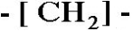 | 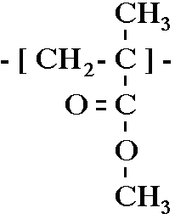 | 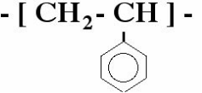 | 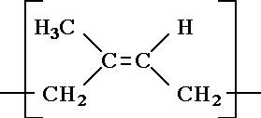

(5) Polymer conformations

5.1 Models for the conformation of polymers

- Polymers are very large and due to their flexibility they can take up an enormous number of configurations by rotation of chemical bonds.
- The shape of the polymer can therefore only be usefully described statistically and one need to use statistical mechanics to calculate the characteristics of even an isolated polymer.
- To be able to investigate the properties of a single polymer and to neglect interactions between polymers, the polymer is placed in a very dilute solution
- Here, we will theoretically investigate the properties of an isolated, single polymer chain in solution (which in addition is linear and consists of only one kind of monomers).

5.2 Freely-jointed chain
- In a simple model we describe a polymer as consisting of a large number of segments freely joined up, where all angles between segments are assumed to be equally likely.

- Monomers are located at positions R_{j} and connected by bonds 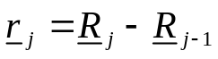 of length 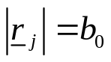.  - The end-to-end vector is 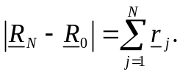  - At any instant, the configuration (arrangement) of the polymer is one realisation of an N-step random walk in three dimensions. | 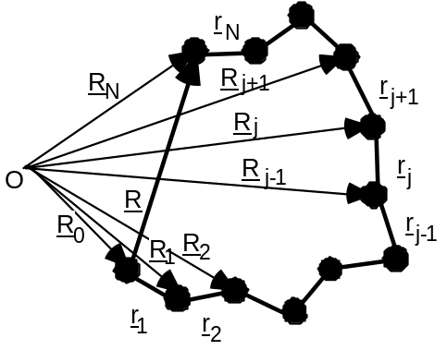
.
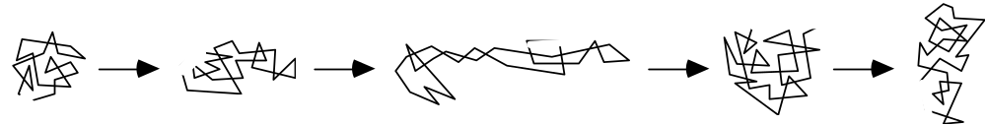

Size and shape of a freely-jointed chain:

- Based on the end-to-end distance R, the size and shape of the chain can thus be described probabilistically:

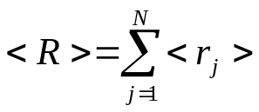
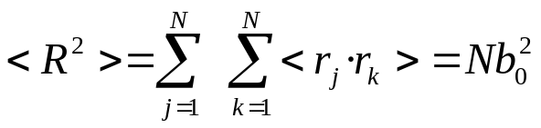
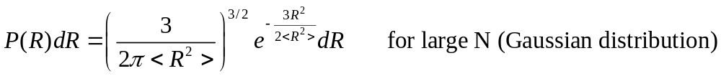

- A more versatile measure of the size for more complicated architectures is provided by the mean square distance from the centre of mass RG, the so-called radius of gyration Rg, which is also a measure of the extension of a (random) chain:
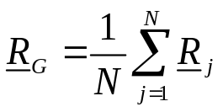
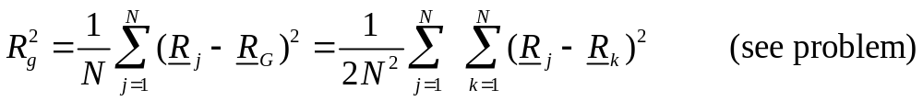

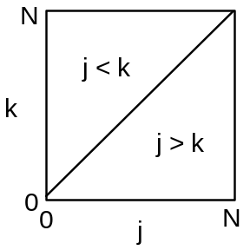
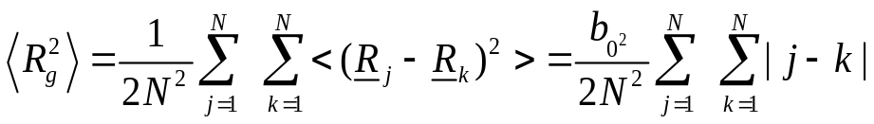

Now transform to continuous variables
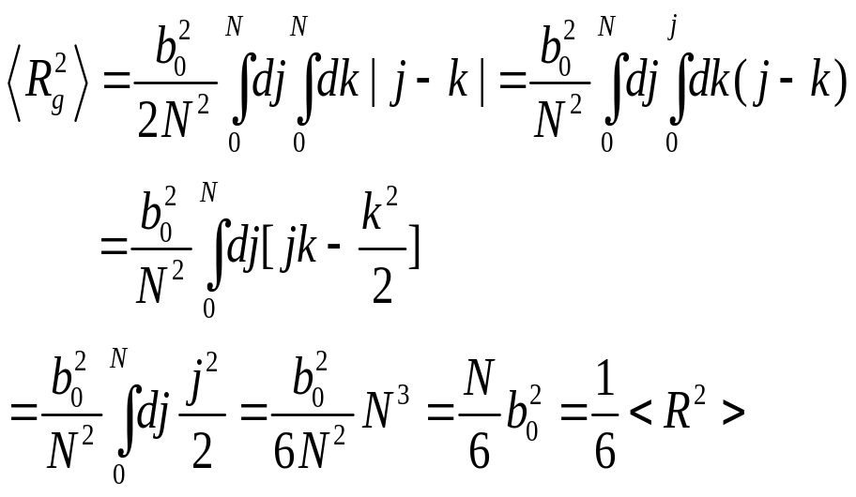

5.3 Freely-rotating chain

- In a polymer molecule the bond angles are usually restricted, which leads to a limited flexibility of the molecule.

- Consider n-butane:
H3C - CH2 - CH2 - CH3

- While the C-C bond angle is fixed at about 120°, rotation about the bond is possible.
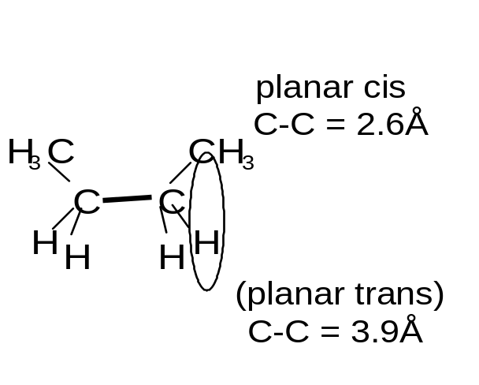

Nevertheless, the potential energy of a configuration depends on the valence angle:

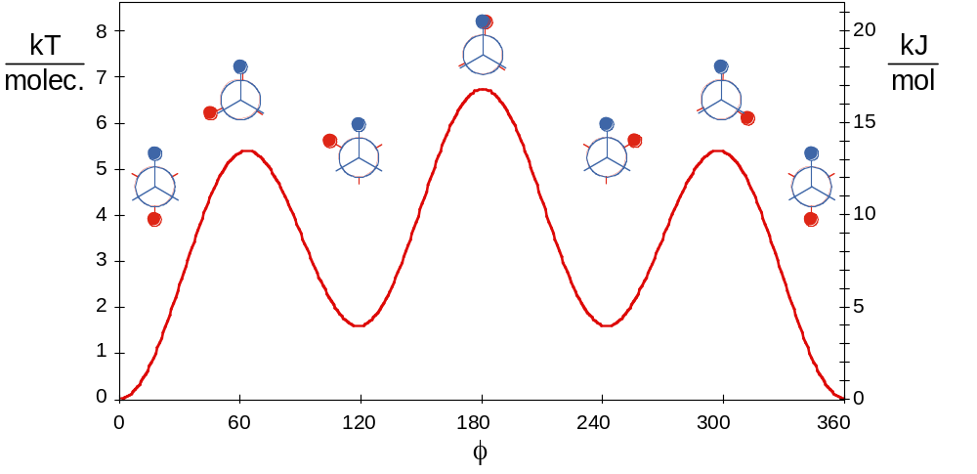

- At low temperatures (kBT < config. energy) the configuration is predominantly trans.

- As the temperature is increased (kBT ~ config. energy), there will also be gauche configurations and at high temperatures (kBT >> config. energy), any angle will be possible.

- This suggests that a more realistic model should be based on fixed angles between bonds, but free rotation about the bonds. This model is called the freely-rotating chain.

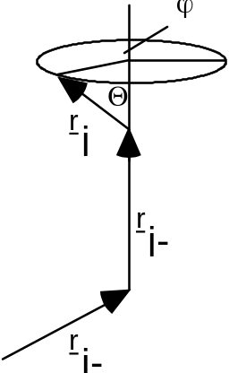Start with a fixed configuration of r₁, r₂, ...., r_{j-1} and then add the next segment r_{j}.

- While the bond angle Θ is given by the chemistry of the molecule, the segment can still freely rotate about the axis defined by r_{j-1}, i.e. ϕ can take any value 0≤ϕ≤2π.
- If we average rj over ϕ, keeping r₁, r₂, ...., r_{j-1} fixed, only the component in r_{j} direction remains:
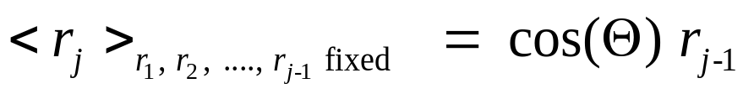

- For the calculation of <R2> we also need <r_{j}·r_{k}>, which we obtain by multiplying both sides with r_{k} and taking the average:

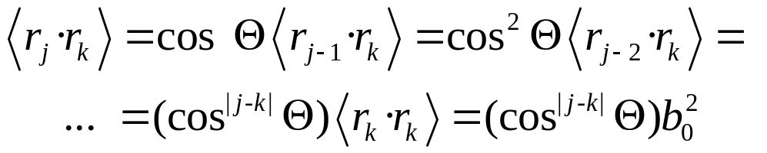

- Since cosΘ < 1, correlations between r_{j} and r_{k} decrease with increasing distance |j-k| between the links and the orientations of distant links become uncorrelated.

- The end-to-end distance <R2> of a freely-rotating chain is hence
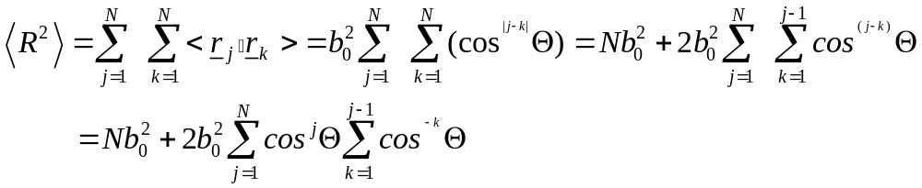
where we used the same argument as above to deal with |j-k|.

- To calculate these two sums we consider the geometric progression:
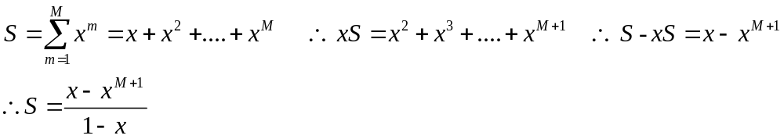
With the help of this formula we get 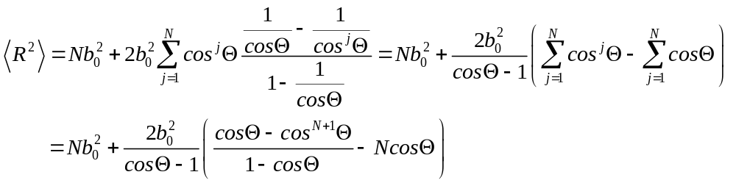

For large N this can be simplified

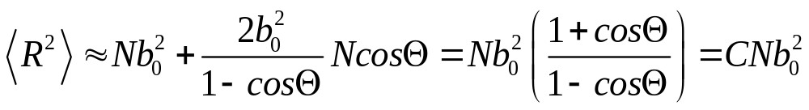

with C = (1+cosΘ)/(1-cosΘ). To get a better idea of the effect of a fixed angle Θ, i.e. going from a freely-jointed to a freely-rotating chain, we look at a few special (but not necessarily very realistic) cases:

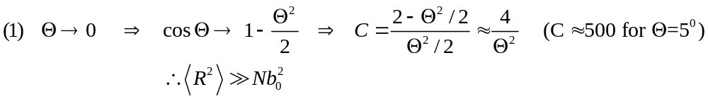
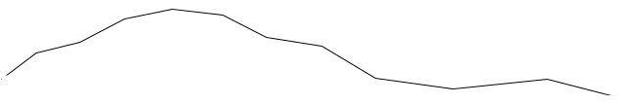

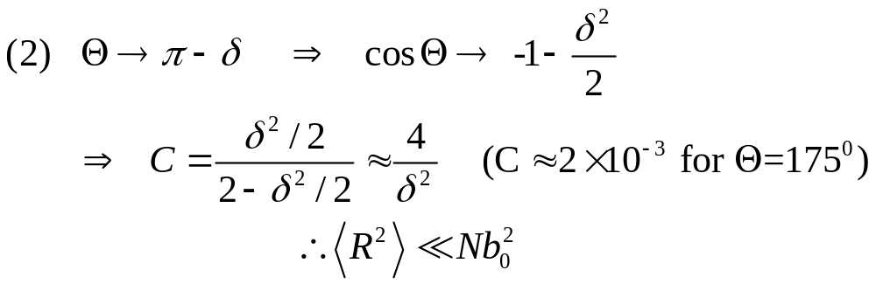
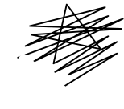

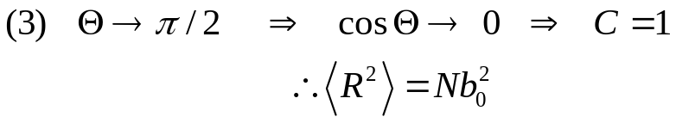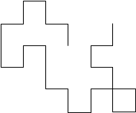

- Again, we get <R2> ∝ N, which suggests that a long freely-rotating chain can be represented by an equivalent freely-jointed chain with N' segments of length b.

- Real and effective chain must have the same actual length (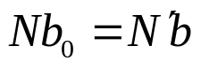) and the same end-to-end distance 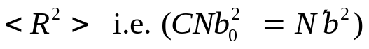. These constraints result in b = Cb₀ and N' = N/C. This has important consequences:

- All sufficiently long flexible chains have the same behaviour and the chemical details are hidden in N' and b. While individual monomer pairs are not totally flexible, groups of monomers are.

- C represents the number of monomers over which the orientational correlation is lost

- b is the so called “Kuhn” statistical segment length (and twice the “persistence length” 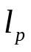)
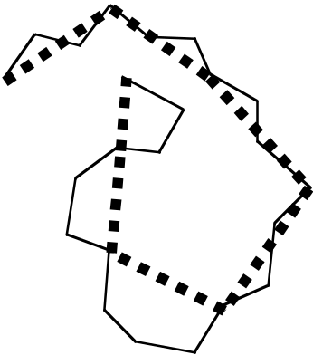

5.4 Excluded volume effects

- The fact that two monomers cannot occupy the same space has consequences on different length scales.

- On a local length scale this prevents neighbouring monomers from coming too close together.

- This effect is taken into account in terms of a restricted bond-angles, which prevents them from overlapping. Non-overlap, i.e. excluded volume, of distant monomers along the chain has also to be taken into account and can have surprisingly large effects.

- Consider the fraction of coil volume (of radius <Rg²>^{1/2} ) actually occupied by monomers:

Volume actually occupied by monomers:
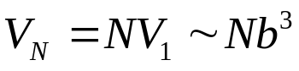 (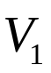 =volume of a monomer)

Hence V occupied by whole coil: 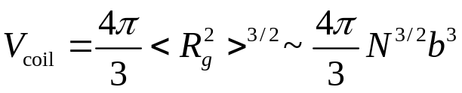
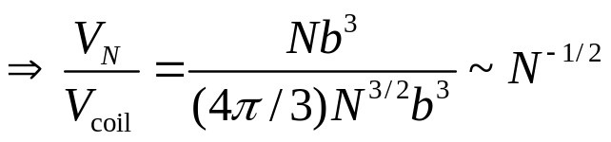
e.g. N = 10⁴ monomers occupy only about 1% of the whole coil volume!

- The overall chain size <R_{g}²>^{1/2} is determined by the competition of two effects:
- Entropy favours a compact chain over the more unlikely stretched configurations
- Repulsive excluded volume interactions want to expand the chain to avoid overlap.

- To analyse this, consider the Helmholtz free energy of a single chain. Chain can be regarded as an assembly of particles with constant volume 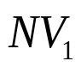 at constant temperature T:

F = U - TS

- The entropy S is given by

S = kB ln (no. of configurations)

For a given R the number of configurations is expected to be proportional to
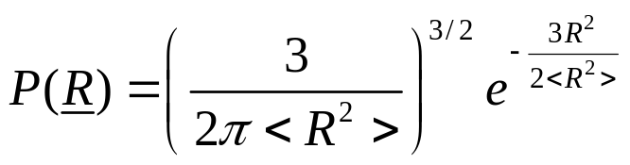
and hence
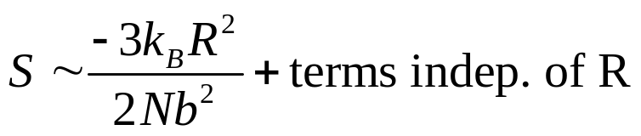

- To estimate the potential energy, disregard the connectivity of the chain and calculate the interaction energy of a 'segment gas' confined in a volume R³. The probability of a monomer lying in this volume is given by the fraction of total coil volume occupied by monomers, which we estimated above to be 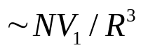.

- Thus the probability of monomer-monomer contacts
is 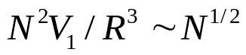. With an energy ε of a monomer-monomer contact, the potential energy 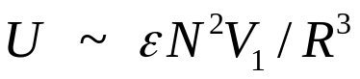.

We thus obtain
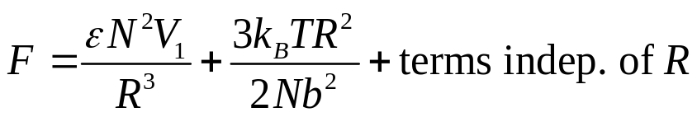

This can be minimized with respect to R, i.e. dF/dR = 0, yielding
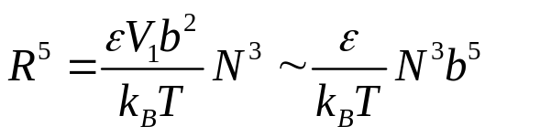

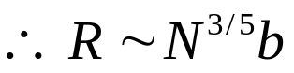
Simulations give a very similar scaling, R ~ N ^{0.588}.

- Thus the chain can no longer be modeled by a random walk, but has to be described by a self-avoiding random walk. The distribution of end-to-end distances is also not Gaussian.

- Although the difference between an exponent of 0.5 (as is characteristic for the freely-jointed and freely-rotating chains, i.e. a random walk) and ≈0.6 (excluded volume chain, i.e. self-avoiding random walk) seems small, it has a large effect at large N.
- For example, for N = 10 ⁴, R = N ^{0.5}b = 100 b, while R = N ^{0.6}b = 251 b, which corresponds to a swelling of the chain by a factor of 2.5.

5.5 Good, poor and theta solvents

- So far, only considered repulsive monomer-monomer interactions.
- However, the type of solvent has a great effect on the polymer size. If there is a high affinity with the solvent ('good solvent') the polymer swells, while it will shrink in a 'poor solvent'.

- Consider a lattice model, where each lattice site has z nearest neighbours.

- Let there be N_{s} solvent molecules, N_{p} monomers and N_{sp} solvent-monomer contacts. The energies of interaction are ε_{ss} for solvent-solvent, ε_{pp} for monomer-monomer and ε_{sp} for solvent-monomer interactions.

- Then the energy of mixing ΔUmix is given by
ΔUmix = U - (Us + Up)
where the energy of pure solvent is 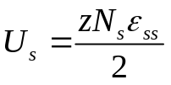 and the energy of pure polymer 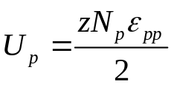

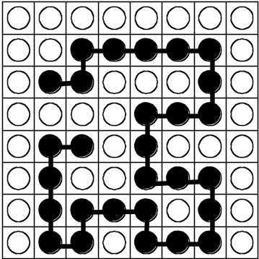

- Hence the energy of solution is 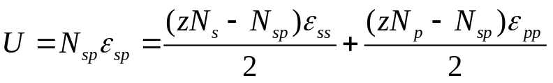

and we obtain for the energy of mixing
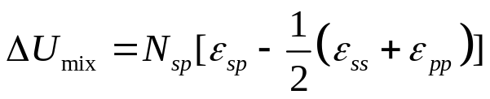

which can be either positive or negative:

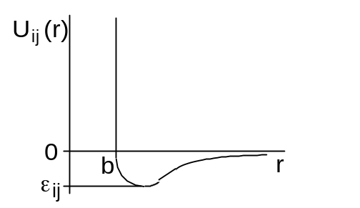
- If we have 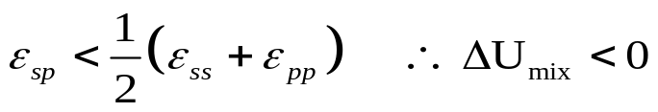

Then we say we have a 'good solvent', because the monomers prefer to be near the solvent molecules. Excluded volume effects then expand the chain.

- On the other hand if 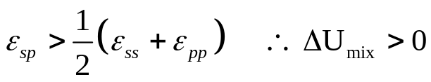, we have a 'poor solvent', because the monomers prefer to be near to each other. The attraction between the different monomers offsets the excluded volume effect.

The importance of the attractions generally depends on temperature.

- At very high temperatures the coil is expanded and the solvent quality is good.

- At very low temperatures, the solvent quality is poor, attraction dominates, the coil collapses and phase separation is observed.

- In between these two limits, there is a temperature, the so-called theta temperature Θ, where the coil has ideal dimensions and the effects of excluded volume and attraction cancel each other. The solvent at T = Θ is called a 'theta solvent'. The stronger the attractions the higher Θ will be, while for weak attractions Θ is low.
(6) Concentrated polymer solutions

- Previously we considered a single polymer in a very dilute solution.
- Now we increase the concentration in steps until we reach bulk polymers.
- The most important regimes of concentration are:

(A) Dilute:

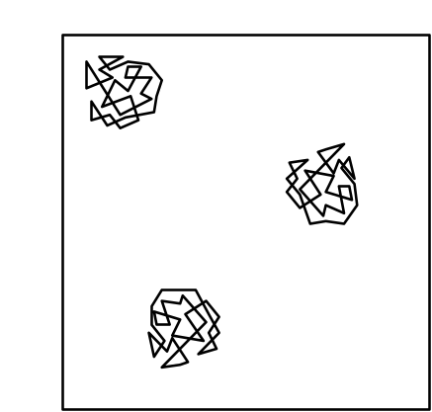

The polymer coils well-separated on average. 'Dilute' means:

concentration in
mass per volume
↓
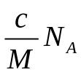 | × | 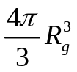 | << 1
number per volume |  | volume of  one coil
volume fraction of coils

(B) Overlap concentration c*:

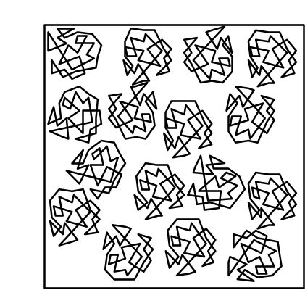

Overlap occurs when the volume fraction of coils reaches unity and thus
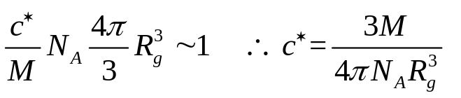
using 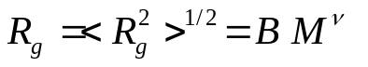 gives
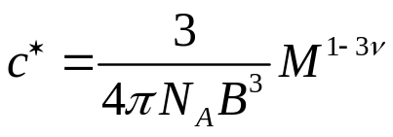

Example: Polystyrene with M = 10⁶ g mol⁻¹ in a good solvent (ν = 0.6) and B = 0.028 nm (g mol^{-1)-0.6} leads to c* = 0.29 kg m⁻³ = 0.29 mg/ml. With the density of polystyrene ρ = 1050 kg m⁻³, the volume fraction of monomers is c*/ρ = 0.28×10⁻³. c* can be very small for large polymers.

(C) Semi-dilute:

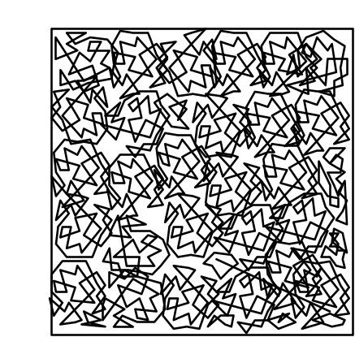

- Concentration larger than c*, but still much smaller than the bulk density.
- The coils interpenetrate and entangle, but the solution is still mostly solvent

(D) Concentrated:

- Here the concentration is very close to the bulk density and the polymer monomers occupy a significant fraction of the total volume.

(E) Bulk polymers:
- Two main classes: cross-linked and not cross-linked.
- First class: Elastomers or rubbers having a low degree of cross-linking and thermosets having a high degree of cross-linking.

- Second class: Thermoplastics, not cross-linked. Most everyday plastic products are thermoplastics. Briefly discuss their behaviour upon cooling (similarities to colloids).

- At high T, free energy dominated by entropy. Melt resembles a random assembly of mobile, intertwined, flexible coils. Density similar to corresponding monomer liquid.

- Upon cooling the potential energy takes over. Bonds are restricted in their rotation leading to configurations which are more straightened out.

- Below the melting temperature Tm, a crystal is the lowest free energy state. But crystallisation, requires significant ordering of the initially random melt and is only possible for slow cooling.

- If the melt is rapidly cooled below the glass transition temperature Tg (< Tm), a glass is formed. Although the polymers can still vibrate, they can no longer move. Solid thermoplastics are frequently a mixture of crystalline and amorphous structures.

Part 3: SURFACTANTS

(7) Surfactants

In these molecules one end contains a 'hydrophilic

(water-loving) part, while the other end is 'hydrophobic' (water-hating). They are called 'amphiphilic' (loving both) molecules, which reflects their structure, or 'surfactants' (from SURFace ACTive AgeNT), which refers to their behaviour in solution.

(8) Self-assembled structures

8.1 Introduction
- Above a so-called critical micellar concentration (cmc) surfactants self-assemble in solution spontaneously into larger structures.

- This allows the hydrophobic parts to crowd together while being 'shielded' by the hydrophilic heads.

- The surfactant assemblies are not held together by chemical bonds, but only by weak interactions (<kBT).

- Their properties are thus determined by balance between different effects, such as the transfer of hydrophobic chains into the core, interactions between the head group and the entropy of mixing.

- Small changes in parameters, for example temperature, salt concentration or pH, thus have large effects on the characteristics of the surfactant aggregates.

- Nevertheless, for given conditions, they have very well-defined properties (shape, size etc.).

8.2 Shape of surfactant assemblies

- Surfactants spontaneously self-assemble into a variety of different structures. Important factors are

- optimal headgroup area a0:
- volume v of the hydrophobic part:
- chain length lc:

- Structure adopted is determined by a balance between entropy, which favours small aggregates, and energy considerations: A certain shape or size might only be possible by imposing a headgroup area a > a0, which is energetically not favourable.

- Spherical micelle:

- Cylindrical micelles:

(C) Bilayers:

Part 4 Glasses

- Glasses may be formed if the cooling rate is so fast that the liquid does not have time to crystallize.
- Alternatively a glass may form if the molecules have some feature to their structure or bonding that inhibits the formation of a crystalline phase.

Examples:

Elements: Sulphur and Phosporous readily form glasses (tetrahedral networks).
Metallic alloys: liquid metals can form glasses if quenched very rapidly (10⁶ K s⁻¹). Such glasses find applications in recording heads and electrical transformers.
Polymer glasses: Due to entanglement effects, polymers form glasses very easily. Eg. polycarbonates (eyeglasses, shatterproof windows) and polymethacrylate (plastic pipes and tubes).
Oxide glasses: Familiar examples are SiO₂ , Na₂O and CaO (all components of window glass).
Organic glasses: Sucrose solution forms a glass used in boiled sweets. Toluene and methanol also readily form glasses.

(10) Relaxation time and viscosity

- At high volume fractions, a particle is effectively trapped by its nearest neighbours, within a ‘cage’.

- To escape the cage, a particle must jump.
- Consider the characteristic time τ between such jumps and its temperature dependence Empirically, one finds a Boltzmann factor relationship
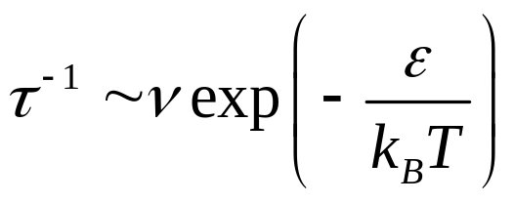

where ν is the typical vibration frequency for a particle rattling around in its cage ≈ escape attempt frequency and ε is the energy of climbing the cage “walls”.

- The relaxation time τ is proportional to another quantity, the viscosity η, a measure of the ability of a liquid to flow.
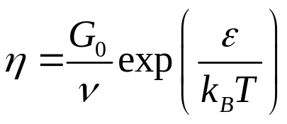

where G₀ is a proportionality constant. This characteristic exponential temperature dependence is known as Arrhenius behaviour.

- While Arrhenius behaviour is observed at high temperature, things are very different at low temperature. The experimentally measured viscosity and the associated configurational relaxation time behave like:
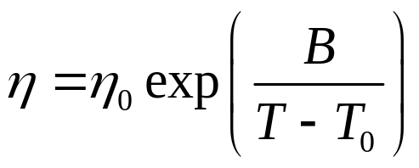

(The Vogel-Fulcher law)

- This implies that the viscosity diverges exponentially at the finite temperature T₀.

- In practical terms, as T₀ is approached from above, one reaches some temperature T_{g} (the glass transition temperature) at which the time for a configuration to relax becomes comparable to the timescale of the experiment itself τ_{exp}.

- At this point, the system falls out of equilibrium with respect to rearrangements of the particle configurations.

Characterising the glass transition T_{g}

- T_{g} is that temperature at which the system falls out of equilibrium on the experimental timescale τ_{exp}.

- In a long experiment, in which T is lowered slowly, the system will have a greater time to and will stay in equilibrium to lower T.

- Thus T_{g} depends on the rate at which we do the experiment.
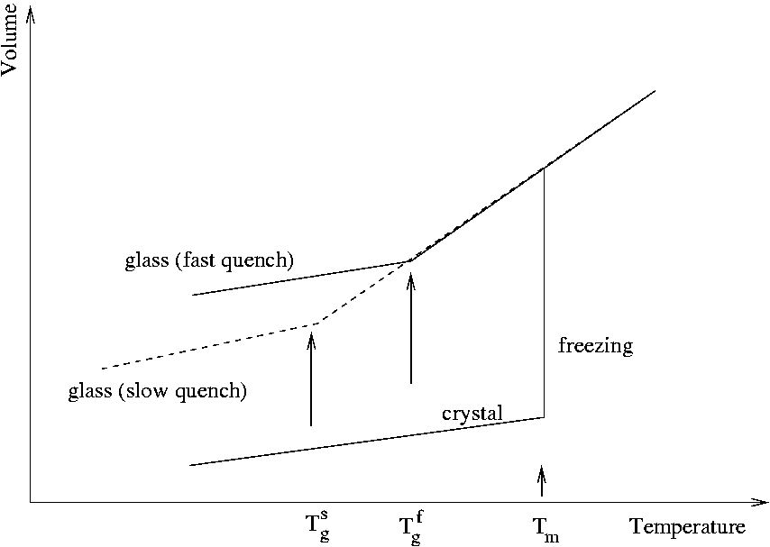

- At, T_{g} the curve exhibits a well defined discontinuity in it slope. The reason why the glass transition is not a true thermodynamic phase transition is that the T at which the discontinuity occurs depends on the history of the sample, i.e. how rapidly it is cooled.

- We say that the glass transition is a kinetic phase transition brought on by the divergence of the structural relaxation time.

A simple picture of the glass transition

- Theories of the glass transition are a matter of intense current research.
- Detailed physics is still not well understood in a comprehensive fashion.
- Simple models offer some insight, in qualitative if not quantitative agreement with experiment.
- One theory is based on idea of cooperativity.

- In a liquid at high T, a molecule can diffuse simply by moving to occupy the space made available by the random local motions of its neighbours.

- At low temperatures and high φ, local motion of neighbours is insufficent to allow diffusion. Instead a number of neighbours must move cooperatively in order to make space for a molecule to move.

- The minimum number of molecules that have to move in unison in order for diffusion of a molecule to take place gives rise to the concept of a cooperative rearranging region.

- As the temperature is lowered the size of this region increases, diverging (with the viscosity) at the Vogel-Fulcher temperature T₀

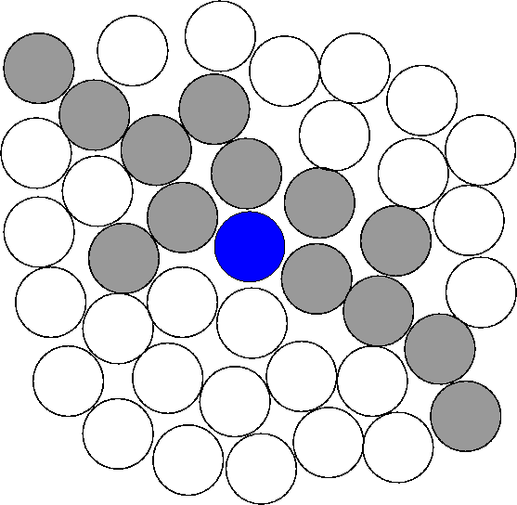
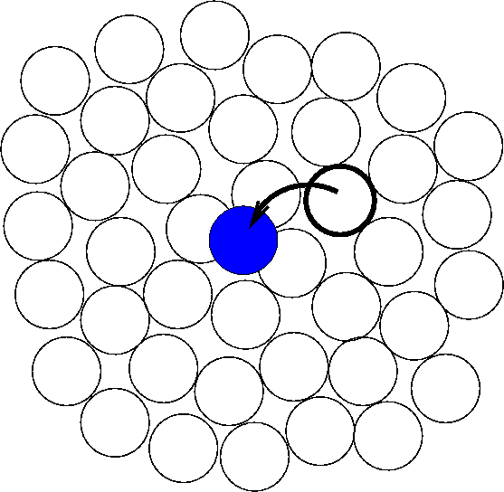

- If we suppose that the energy barrier for a single molecule to move is μ and there are z molecules in the cooperatively rearranging region, then the thermal activation barrier for motion is
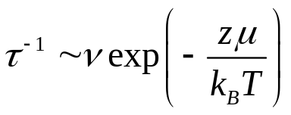

with ν the microscopic vibration frequency. Within this model, the non Arrhenius behaviour of the relaxation time derives from the increase in the number of molecules that have to move cooperatively as temperature decreases, i.e. the T dependence of z.

